**CENTRAL VALLEY LATE FALL CHINOOK SALMON[1]**

***Oncorhynchus tshawytscha* ssp.**

**Status: Class 2. Species of Special Concern.**

**Description:** Central Valley late fall Chinook salmon are morphologically similar to other Chinook salmon (see Central Valley fall Chinook account). They tend to be larger than other Central Valley Chinook salmon, reaching 75-100 cm TL and weighing up to 9-10 kg or more.

**Taxonomic Relationships:** The four runs of Chinook salmon in the Central Valley are differentiated by their life history characteristics including maturity of fish entering fresh water, time of spawning migrations, spawning areas, incubation times, and migration timing of juveniles (Moyle 2002). The late fall run population is part of the Central Valley Chinook genetic complex; all populations within the Central Valley are more closely related to each other than they are to populations outside the valley. Late fall Chinook, however, were only fully recognized as a distinct run in 1966 after the construction of Red Bluff Diversion Dam (see abundance section). Using modern genetic techniques, late fall Chinook can be distinguished from the other runs (Williams 2006) although NMFS manages them as part of the Central Valley fall run ESU because of their close relationship to it. We follow Yoshiyama et al. (1998), Moyle (2002), Williams (2006) and others in recognizing it as a genetically-distinct life history type within the Central Valley Chinook salmon complex.

**Life History:** The basic life history of Central Valley (CV) late fall Chinook is similar to that of other Chinook salmon runs (see CV fall Chinook salmon account, Moyle 2002, Williams 2006), although it is much less well known in its details because of its comparatively recent recognition and its tendency to ascend and spawn at times when the Sacramento River is most likely to be high, cold, and turbid, making the fish hard to study. In the past, these migrating fish were a mixture of age classes, ranging from two to five years old. At the present time a majority of the fish are probably three-year olds. Late fall Chinook mostly migrate upstream in December and January as mature fish, although they have been recorded from November through April (Williams 2006). Spawning occurs mainly in late December and January, shortly after the fish arrive on the spawning grounds, although it may extend into April in some years (Williams 2006). Emergence from the gravel starts in April and all fry have usually emerged by early June. The juveniles may hold in the river for 7-13 months before moving out to sea. Peak migration of smolts appears to be in October. However, there is evidence that many migrate out at younger ages and smaller sizes. Williams (2006) indicates that if DFG size criteria are used, downstream migrating late fall Chinook can be found in most months of the year.

**Habitat Requirements:** The specific habitat requirements of late fall Chinook have not been determined, but they are presumably similar to other Chinook salmon runs and optimal conditions fall within the range of physical and chemical characteristics of the unimpaired Sacramento River above Shasta Dam. See the CV fall Chinook salmon account for details on temperature and other requirements. For a more specific summary of Central Valley Chinook salmon requirements see Stillwater Sciences (2006) and Moyle (2002).

**Distribution:** Currently, CV late fall Chinook are found mainly in the Sacramento River, where most spawning and rearing of juveniles takes place in the reach between Red Bluff Diversion Dam (RBDD) and Redding (Keswick Dam). However, varying percentages of the total run spawn downstream of RBDD in some years. In 2003, for example, 3% of the fish spawned below the dam, while in 2004 no fish spawned below the dam (Kano 2006a, b). R. Painter (DFG, pers. comm., 1995) indicated that late fall Chinook have been observed spawning in Battle Creek, Cottonwood Creek, Clear Creek, Mill Creek, Yuba River and Feather River, but these are presumably at best a small fraction of the total population. The Battle Creek spawners are likely derived from fish that originated from the Coleman National Fish Hatchery. The historic distribution of CV late fall Chinook is not well documented, but they most likely spawned mostly in the upper Sacramento and McCloud rivers in reaches now blocked by Shasta Dam, as well as in sections of major tributaries where there was adequate cold water in summer. There is also some evidence they once spawned in the San Joaquin River in the Friant region and in other large San Joaquin tributaries (Yoshiyama et al. 1998).

**Trends in Abundance:** The historic abundance of CV late fall Chinook is not known because it was recognized as distinct from fall Chinook only after Red Bluff Diversion Dam (RBDD) was constructed in 1966. In order to get past the dam, salmon migrating up the Sacramento River ascend a fish ladder in which they could be counted with some accuracy for the first time. The four Chinook salmon runs present in the river (fall, late fall, winter, spring) were revealed as peaks in the counts, although salmon passed over the dam during every month of the year. In the first 10 years of counting (1967-1976) the run averaged about 22,000 fish; in the next 10 years (1982-1991) the run averaged about 9,700 fish (Yoshiyama et al. 1998). Since 1991, estimates of abundance are less accurate but in 1992-2007, total numbers were estimated to have averaged 20,777 fish, with a wide range in annual numbers, including a 1998 production total of over 80,000 fish. The less accurate counts were the result of opening the gates at Red Bluff for free passage of the listed winter Chinook salmon from September 15 to May 15 starting in 1992. This made estimation of late fall Chinook spawner numbers more difficult because most of the fish could not be counted while ascending the fish ladders as they had been previously. In 1992-1996, estimates were made by extrapolating from counts of only part of the run. These numbers are extremely low and unreliable (Figure 1). In 1998, DFG initiated surveys based on carcass and redd counts from airplanes and estimated that over 35,000 late fall Chinook had spawned above Red Bluff Diversion Dam. Subsequent surveys have resulted in lower estimates (e.g. 5,000 in 2003) but with variability from year to year. The numbers seem to indicate that measures taken to benefit winter Chinook salmon have probably also benefited late fall run. It is possible that fish from Coleman National Fish Hatchery on Battle Creek are contributing to the spawning population in the main stem Sacramento River (Figure 2).

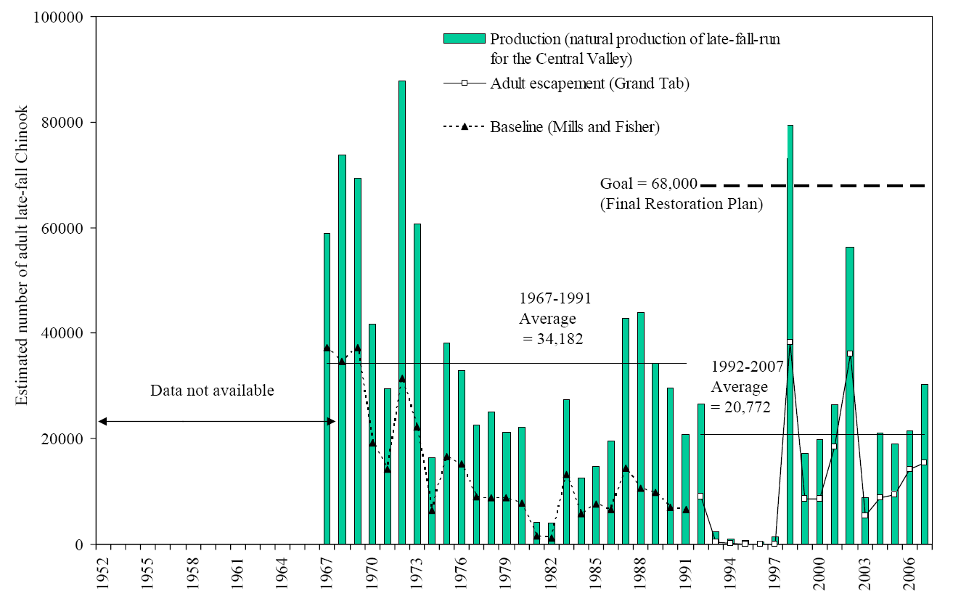

**Figure 1.** Estimates of late fall run Chinook salmon spawners 1967-2007, between Red Bluff Diversion Dam and Keswick Dam. http://www.delta.dfg.ca.gov/afrp/documents/Doubling_goal_graphs_031308.pdf



**Figure 2.**  Numbers of late fall run Chinook salmon in Battle Creek, where the Coleman Fish Hatchery is located. From DWR 2005.

**Nature and Degree of Threats:** For late fall Chinook salmon, the causes of population decline from pre-dam numbers are poorly documented, but likely are similar to those of the other three runs, in whose accounts more general factors affecting status are discussed. Some of principal factors more specifically affecting late fall Chinook salmon status, past and present, seem to be (1) dams, (2) loss of habitat, (3) fisheries, (4) outmigrant mortality, and (5) hatcheries (Table 1).

|  |  |  |
| --- | --- | --- |
|  | Rating | Explanation |
| Major dams | High | Dams deny access to historic spawning grounds |
| Agriculture | High | Diversions and levees reduce habitat |
| Grazing | Low |  |
| Rural residential | Low | Constant source of small changes to river banks and pollution |
| Urbanization | Intermediate | Urban areas along Sacramento River and tributaries restrict habitat |
| Instream mining | Intermediate | Gravel mining and legacy effects of placer mining reduce habitat |
| Mining | High | Iron Mountain Mine always poses a threat. |
| Transportation | Intermediate | Roads line banks and cross rivers |
| Logging | Low | Generally low impact because occurs at higher elevations |
| Fire | Low | Few impacts on main river likely |
| Estuary alteration | High | San Francisco Estuary highly altered |
| Recreation | Low | Water recreation can disturb spawners and migrants |
| Harvest | High | Ocean and in river harvest have been high in past |
| Hatcheries | High | Effects of hatchery fish (including fall Chinook) on late fall chinook not well understood but likely high |
| Alien species | High | Predation and competition a growing concern |

**Table 1.** Major anthropogenic factors limiting, or potentially limiting, viability of populations of CV late fall Chinook salmon in California, where a factor rated “high” is a major limiting factor, a factor rated “intermediate” is a factor that has the potential to be a major limiting factor but has had only a moderate effect so far on population viability, and a factor rated “low” has a low or unknown effect on population viability. Certainty of these judgments is moderate.

*Dams.*  When Shasta and Keswick Dams were built in the 1940s, they denied late fall Chinook access to upstream spawning areas where spring water originating from Mt. Shasta, as well as extended snow-melt, kept water temperatures cool enough for successful spawning, egg incubation and survival of juvenile salmon all year around. At present late fall Chinook are largely dependent on cold water releases from Shasta and Oroville dams. Large dams on the Sacramento River and its tributaries have not only denied salmon access to historic spawning grounds, but they have reduced or eliminated recruitment of spawning gravels into the river beds below the dams and altered temperature regimes. Loss of spawning gravels in the Sacramento River below Keswick Dam is regarded as a serious problem and large quantities of gravel are now trucked to the river and dumped in, mainly to provide spawning sites for winter Chinook. However, it is likely that late fall salmon also use these gravel deposits. Warm water temperatures are potentially a problem in this reach, during drought years when the cold water pool in Shasta Reservoir is reduced. The installation of means to provide cooler water in summer for winter Chinook has presumably also benefited late fall Chinook.

The effects of Red Bluff Diversion Dam (RBDD) were more subtle and not recognized until fairly recently. This dam apparently delayed passage to upstream spawning areas and also concentrated predators, increasing mortality on out-migrating smolts. Kope and Botsford (1990) documented that the overall decline of Sacramento River salmon was closely tied to the construction of RBDD. Raising the dam’s gates for much of the year to allow salmon passage has apparently alleviated much of this problem.

*Agriculture*. Outmigrant mortality of both fry and smolts is undoubtedly a factor affecting late fall Chinook abundance as it is for all runs of salmon in the Sacramento-San Joaquin drainage. Small numbers of outmigrants are presumably entrained at the larger irrigation diversions along the Sacramento River that are operating during the migration period. At the same time, extensive bank alteration, especially rip-rapping, had reduced the amount of cover available to protect outmigrants from striped bass, terns, herons, and other predators. See CV fall Chinook account for further discussion of these issues.

*Urbanization.* See CV fall Chinook account.

*Mining.* Existing gravel mining operations and legacy effects of past gravel mining, as well as placer and hydraulic mining presumably continue to affect late fall Chinook salmon but the effects are largely unknown. Iron Mountain Mine, a gigantic EPA Superfund Site full of toxic metals and acidic water, is poised above the key spawning areas in the Sacramento River. Should Spring Creek dam (which contains the toxic materials) fail or other factors cause wastes to released into the river, the results could be catastrophic for all fish in the upper river.

*Estuary alteration.* Once the fish reach the Delta, the upper part of the San Francisco Estuary, there is a complex series of factors that affect their survival (Brandes and McClain 2001). Basically when outflows are high enough so water exports by pumping plants of the State Water Project and the Central Valley Project do not affect seaward movement, survival is high. At lower river flows and higher exports, juvenile Chinook can be entrained in large numbers, are consumed by predators in Clifton Court Forebay and other off-channel areas, and/or are otherwise diverted from their downstream migration into unfavorable habitat. As discussed in the fall Chinook account, the changing of the estuary from a diverse and productive system that favored salmon life history diversity to one that is fairly hostile to juvenile salmon has presumably resulted in a loss of biocomplexity within the species, a biological insurance policy (Hilborn et al 2003).

*Harvest.*  The effects of harvest on Central Valley salmon in general is discussed at length by Williams (2006). The actual harvest rates of late fall Chinook salmon are not known, but it is highly likely that they are harvested at the same rates as fall Chinook, the principal remaining run in the Sacramento River. Although hatcheries exist to sustain fisheries and hatchery fish can sustain higher harvest rates than wild fish, fisheries do not discriminate between them. The fisheries are presumably therefore taking a disproportionate number of wild late fall Chinook. Other effects are discussed in the fall run Chinook account.

*Hatcheries.* Late fall Chinook are reared in large numbers (ca. 1 million smolts released each year) in Coleman National Fish Hatchery on Battle Creek. This has been taking place since the 1950s, even though the run was not formally recognized until 1973 (Williams 2006). Hatchery brood stock selection for late fall Chinook includes both fish naturally returning to Battle Creek and those trapped below Keswick Dam. The production goal is 100 million smolts per year, which are released into Battle Creek in November through January (Williams 2006). Large numbers are needed because survival rates are low (0.78% at Coleman). Williams (2006) after an exhaustive review of the literature and hatchery practices in California concludes that hatcheries almost certainly have deleterious effects on wild populations of salmon, making it more difficult to achieve recovery goals for naturally-spawning late fall Chinook salmon. Late fall Chinook juveniles and smolts presumably also have interactions with the abundant fall Chinook salmon juveniles released from hatcheries.

*Alien species.* See CV fall Chinook account.

**The integrated view of factors causing salmon declines presented in the CV fall Chinook account also applies to CV late fall Chinook salmon.**

**Effects of Climate Change.** The effects of climate change on late fall Chinook salmon are similar to those discussed for CV fall Chinook salmon. However, particularly critical for late fall Chinook is maintaining a cold water pool in Shasta and Oroville reservoirs to keep water in the Sacramento River cold enough to maintain the fish year around. Keeping the cold water pool will be increasingly difficult during periods of extended drought and increasing water temperatures. Thus spring-fed Battle Creek may be crucial as a refuge during periods of drought.

**Status Determination. Score = 2.** In the past 10 years, numbers of CV late fall Chinook salmon have fluctuated but appear to be comparable to numbers in the 1970s and 1980s. According to NMFS, they “continue to have low, but perhaps stable, numbers.”

(<http://www.nmfs.noaa.gov/pr/pdfs/species/chinooksalmon_highlights.pdf>). They are nevertheless vulnerable to extinction within the next 100 years or less because of their relatively small population size (Table 2). The limited area for spawning and rearing would seem to make the single population exceptionally vulnerable to changes in water quality and flow in the Sacramento River, such as might be created by an extended drought or a major spill of toxic materials from Iron Mountain Mine. Their persistence depends entirely on operation of water projects (Shasta Dam) and hatchery operations, which can easily be changed. The late fall Chinook is considered to be a species of special concern by the California Department of Fish and Game and the National Marine Fisheries Service, although the latter agency lumps them with the fall ESU in this category.

|  |  |  |
| --- | --- | --- |
| Metric | Score | Justification |
| Area occupied | 1 | Only one population present in Sacramento River. |
| Effective population size | 3 | If average population is 10,000 spawners then the effective population is likely much smaller due to hatchery affects |
| Dependence on intervention | 2 | Almost entirely dependent on dam operation and a hatchery for persistence, plus stream restoration actions. |
| Tolerance | 3 | Moderate physiological tolerance, multiple age classes |
| Genetic risk | 2 | Risk of hybridization with other runs and hatchery fish is high, likely resulting in reduced fitness in the wild |
| Limiting factors | 2 | See Table 1. |
| Climate change | 1 | Just one population, in the Sacramento River, which requires cold water from Shasta Reservoir, so vulnerable to extended drought. |
| Average | 2.2 | 15/7 |
| Certainty (1-4) | 3 | Least studied of Central Valley Chinook runs |

**Table 2.** Major anthropogenic factors limiting, or potentially limiting, viability of populations of Central Valley late fall Chinook salmon in California, where a factor rated “high” is a major limiting factor, a factor rated “intermediate” is a factor that has the potential to be a major limiting factor but has had only a moderate effect so far on population viability, and a factor rated “low” has a low or unknown effect on population viability. Certainty of these judgments is 3.

**Management Recommendations:** At present, less management is done to directly benefit late fall Chinook salmon than for any other run in the Sacramento River, mostly because the least is known about it and because it is considered a segment of the fall Chinook population by NMFS. Thus our principal recommendation is that CV late fall Chinook should be treated for management purposes as a distinct population segment of Central Valley Chinook salmon and specific management measures made to enhance their populations.

Fortunately, this run should benefit considerably from measures being made to enhance winter and spring Chinook salmon populations in the river, as well as additional actions recommended by NMFS in their 2009 *Biological and Conference Opinion on the Long-Term Operations of the Central Valley Project and State Water Project and Related Documents* (http://swr.nmfs.noaa.gov/ocap.htm). However, specific studies should be undertaken to better understand the environmental requirements of this run because the population needs protection at all stages of its life cycle. The Anadromous Fish Restoration Program (AFRP) has set a goal in their final restoration plan of an average production (escapement plus catch in fishery) of 44,000 fish per year, although the official doubling goal (required in the Central Valley Project Improvement Act) is 68,000 fish (http://www.delta.dfg.ca.gov/afrp/). Whether or not existing habitat is enough to sustain populations at either level is problematic.

Restoration will require: (1) continuing to provide passage of adults to holding and spawning areas, through Red Bluff Diversion Dam, (2) protecting adults in spawning areas, (3) establishing additional spawning areas (e.g., Battle Creek, San Joaquin River), (4) providing passage flows for out-migrating juveniles to get through the Delta as rapidly as possible, (5) maintaining and expanding rearing habitat for juvenile fish, including the mainstem and floodplains, (6) regulating the fisheries to minimize impact, and (7) reducing the effects of hatchery fish on wild populations. Most of these require continuous, creative management, as well as greatly improved monitoring programs for both hatchery and wild fish (Williams 2006).

An aspect of their conservation that needs to be carefully evaluated is the practice of rearing large numbers in Coleman Hatchery, because they appear to an increasingly large proportion of the total population (Williams 2006) and likely have an adverse effect on wild populations.

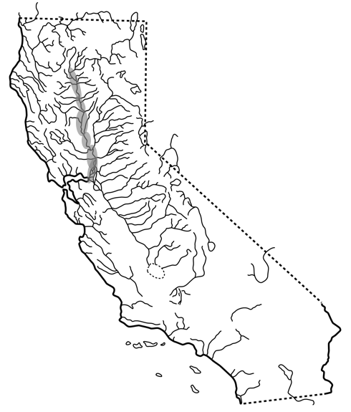

**FIGURE X.** Distribution of Central Valley Late Fall Chinook, *Oncorhynchus tshawytscha* ssp., in the Sacramento River and tributaries of California.

1. This account is a modification and update of the account in Moyle, Israel, and Purdy (2008).